Deontae Craig  University of Iowa  Big Ten Football, 2020 class  Hawkeyes  Defensive Lineman  Graduate of Culver Academies, Culver, Indiana  Head Football Coach: Kirk Ferentz  Text message update from Deontae, July 17, 2020, from Iowa.  Anyonecanachieve.com | 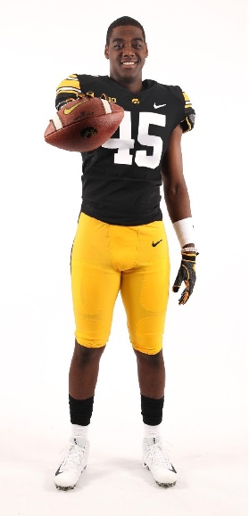

Tell us about the transition from High School at Culver to University of Iowa?
Deontae: “So far the transition has been going really well. The hardest adjustment has been waking up really early and a lot of free time. I am planning to major in sports science because it seems like an interesting field to get into involving sports. I am taking rhetoric, elementary psychology and a couple other lecture hall courses. Eventually, I want to get a Ph.D. in something, but with sports it might be kind of hard, so I’ll see how I feel about it in a few years”.
Anyonecanachieve.com: In the last post, Deontae mentioned that he was inspired by the Basketball career of Kobe Bryant. Kobe Bryant played basketball for the Los Angeles Lakers in the NBA for 20 seasons straight out of High School. Bryant won many accolades during his long career including NBA championships, All Star, MVP and many more. Sadly, Bryant died in a tragic private airplane crash on January 26, 2020.) Deontae continues: “I think about Kobe Bryant every day. He’s my phone wallpaper. I wear his number in basketball and I look at every single social media post about him. I wrote mamba forever on my shoes and cleats after he passed away so I know his mentality will live in whatever I do.”
Anyonecanachieve.com: Thanks Deontae and good luck at University of Iowa. Good luck in academics and sports. Let’s hear from you again soon.

